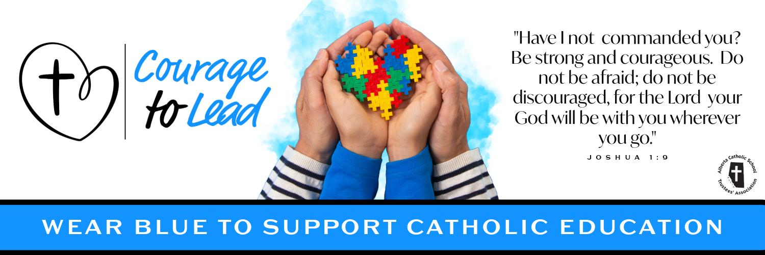
Catholic Education Week 2024
Liturgy of the Word - Ascension of Our Lord
Thursday, May 9, 2024 - Catholic Education

Introduction
Today, as we continue our celebration of Catholic Education, we acknowledge Catholic Education day on the feast day of the Ascension our Lord.

Today we also give thanks for our educational leaders, our Superintendents and Trustees

Our education leaders are responsible for various aspects of the educational system, including governance, policy-making, and decision-making.

Let us also follow their courageous yes and pray for them as they make impactful decisions for the betterment of Catholic Education

Please join us in the singing of our opening hymn: Glory and Praise to our God

Suggestions:
Verse 1 & 2 (until 1:46) Glory and Praise to our God - https://www.youtube.com/watch?v=c7GiWZG-AI4&list=RDEMN1f6BMaSJZnt2Tnztg3Hyw&index=14

Opening Prayer
Heavenly Father, we thank you for the precious gift of Catholic Education.

As we celebrate Catholic Education Week, give us the grace to carry out our daily tasks with a positive attitude and an eagerness to learn more about you.

Help us to walk confidently in your footsteps so we can courageously lead others to your loving heart.

We ask this in the name of the Father, and of the Son and of the Holy Spirit. Amen

Reading
A reading from the Acts of the Apostles:

In the first book, Theophilus, I wrote about all that Jesus did and taught from the beginning until the day when he was taken up to heaven, after giving instructions through the Holy Spirit to the Apostles whom he had chosen. After his suffering he presented himself alive to them by many convincing proofs, appearing to them during forty days and speaking about the kingdom of God.

While staying with them, he ordered them not to leave Jerusalem, but to wait there for the promise of the Father. “This,” he said, “is what you have heard from me; for John baptized with water, but you will be baptized with the Holy Spirit not many days from now.”

So when they had come together, they asked him, “Lord, is this the time when you will restore the kingdom to Israel?” He replied, “It is not for you to know the times or periods that the Father has set by his own authority. But you will receive power when the Holy Spirit has come upon you; and you will be my witnesses in Jerusalem, in all Judea and Samaria, and to the ends of the earth.”

When he had said this, as they were watching, he was lifted up, and a cloud took him out of their sight. While he was going and they were gazing up toward heaven, suddenly two men in white robes stood by them. They said, “Men of Galilee, why do you stand looking up toward heaven? This Jesus, who has been taken up from you into heaven, will come in the same way as you saw him go into heaven.”
[Acts 1.1-11]

The Word of the Lord.
R: Thanks be to God.

Gospel
The Lord be with you.
R. And with your Spirit.

A reading from the holy gospel according to John.
R. Glory to you, Lord

Jesus appeared to the eleven, and he said to them, “Go into all the world and proclaim the good news to the whole creation. The one who believes and is baptized will be saved; but the one who does not believe will be condemned. And these signs will accompany those who believe: by using my name they will cast out demons; they will speak in new tongues; they will pick up snakes in their hands, and if they drink any deadly thing, it will not hurt them; they will lay their hands on the sick, and they will recover.”

So then the Lord Jesus, after he had spoken to them, was taken up into heaven and sat down at the right hand of God. And they went out and proclaimed the good news everywhere, while the Lord worked with them and confirmed the message by the signs that accompanied it. [Mark 16.15-20]

The gospel of the Lord.
R. Praise to you, Lord Jesus Christ.

Prayers of the Faithful
Response is: Lord, hear our prayer.
R. Lord, hear our prayer.

For all leaders in Catholic Education that through the guidance of the holy spirit they may grow closer to God in all that they do, we pray to the lord.

For the pope, that the risen lord may grant him good health and strength as he continues to lead the church with courage, we pray to the lord.

For Catholic Education: That during our celebrations of Catholic education Week, we may live out the mission of “Courage to Lead” with conviction, we pray to the Lord

For all those who are sick in our communities and all those who suffer that they may find help and consolation, we pray to the Lord.

For all our personal intentions. *pause* we pray to the lord.

Closing Prayer
Father, on Catholic Education Day we give thanks for all those men and women who have given their talents to educating our young people.

Through the challenges they encounter each day, lead them to an ever deeper appreciation of the sacred duty to which you have called them.

Thank you for all those who lead our Catholic schools.

May they be people of integrity so that they can be witnesses as well as teachers. We pray that the schools they lead will become places where our young people can experience your love in their lives.

Thank you for our Catholic schools.

Help us to pray without ceasing, to work without wavering and to give without grudging in order to ensure the future of Catholic education for all of our children.

We make this prayer through your Son, Jesus Christ, our teacher and our Lord,
Amen.

Recessional Hymn
Verse 3 (starts at 1:46) Glory and Praise to our God - https://www.youtube.com/watch?v=c7GiWZG-AI4&list=RDEMN1f6BMaSJZnt2Tnztg3Hyw&index=14

