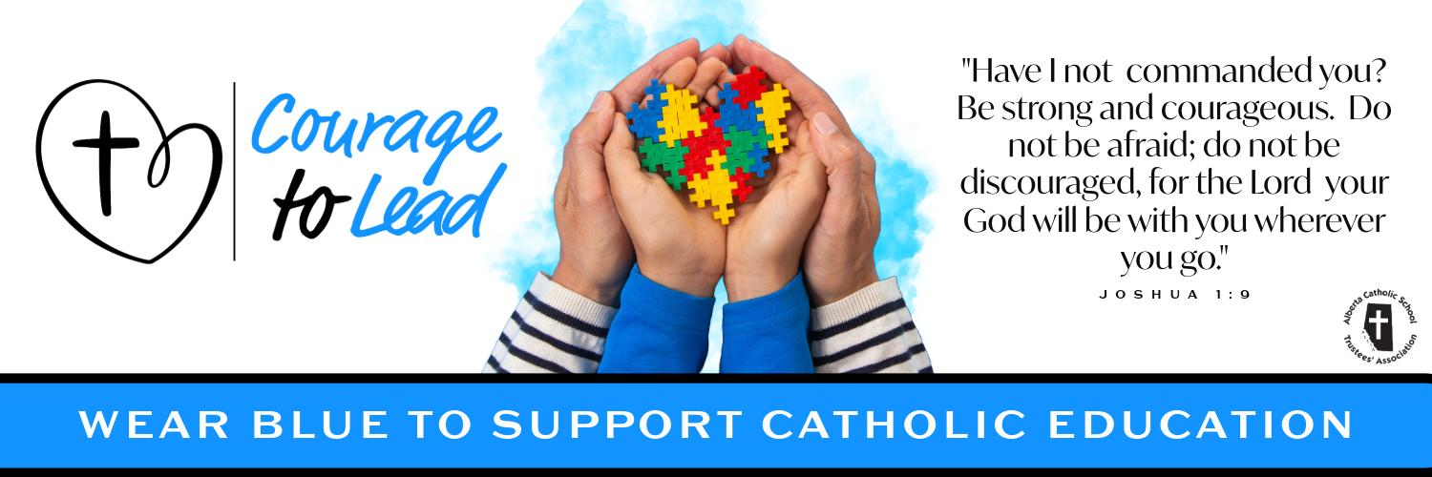
Catholic Education Week 2024
Liturgy of the Word
Friday, May 10, 2024

Introduction
Today, as we continue our celebration of Catholic Education, we give thanks for our Church Leadership - our priests, bishops and the Holy Father.

Our Church leaders provide spiritual guidance and formation for our entire Catholic Education Community.

As we finish off Catholic Education week, let us think of ways we can continue to live out our mission and have the “Courage to lead” others to the Lord.

Please join us in the singing of our opening hymn: Faith of our Fathers

Suggestions:
Verse 1 (until 1:05) Faith of our Fathers - https://www.youtube.com/watch?v=7EVPVS9EGeQ

Opening Prayer
Heavenly Father, we thank you for the precious gift of Catholic Education.

As we celebrate Catholic Education Week, give us the grace to carry out our daily tasks with a positive attitude and an eagerness to learn more about you.

Help us to walk confidently in your footsteps so we can courageously lead others to your loving heart.

We ask this in the name of the Father, and of the Son and of the Holy Spirit. Amen

Gospel Reading
The Lord be with you.
R. And with your Spirit.

A reading from the holy gospel according to John.
R. Glory to you, Lord

When Jesus knew that his hour had come to depart from this world and go to the Father, he said to the disciples: “Very truly, I tell you, you will weep and mourn, but the world will rejoice; you will have pain, but your pain will turn into joy. When a woman is in labour, she has pain, because her hour has come. But when her child is born, she no longer remembers the anguish because of the joy of having brought a human being into the world. “So you have pain now; but I will see you again, and your hearts will rejoice, and no one will take your joy from you. On that day you will ask nothing of me. Very truly, I tell you, if you ask anything of the Father in my name, he will give it to you.” [John 16.20-23a]

The gospel of the Lord.
R. Praise to you, Lord Jesus Christ.

Prayers of the Faithful
Response is: Lord, hear our prayer.
R. Lord, hear our prayer.

For all leaders in Catholic Education that through the guidance of the holy spirit they may grow closer to God in all that they do, we pray to the lord.

For the pope, that the risen lord may grant him good health and strength as he continues to lead the church with courage, we pray to the lord.

For Catholic Education: That during our celebrations of Catholic education Week, we may live out the mission of “Courage to Lead” with conviction, we pray to the Lord

For all those who are sick in our communities and all those who suffer that they may find help and consolation, we pray to the Lord.

For all our personal intentions. *pause* we pray to the lord.

Closing Prayer
Heavenly Father, we pray for all our Church leaders, especially those who serve our Catholic Schools.

Help them be strong in their vocation and set their souls on fire with love for you people.

Grant them the wisdom, understanding and strength they need to follow in the footsteps of Jesus.

We ask this in the name of the Father, and of the Son and of the Holy Spirit. Amen.

Recessional Hymn
Verse 2 (start at 1:05) Faith of our Fathers - https://www.youtube.com/watch?v=7EVPVS9EGeQ

