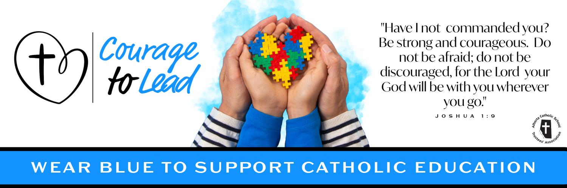
Catholic Education Week 2024
Liturgy of the Word
Tuesday, May 7, 2024

Introduction
Today, as we continue our celebration of Catholic Education, we give thanks for the gift of our students, who are at the very heart of the mission of our Catholic Schools.

We reflect on the courage of the apostles as they carried out their mission of spreading the gospel to all nations.

Let us celebrate their courageous yes and learn how to follow in their footsteps.

Please join us in the singing of our opening hymn: Lead me Lord

Suggestions:
Verse 1, (up to 1:06) Lead me Lord - https://www.youtube.com/watch?v=osbo-4SCkbg

Opening Prayer
Heavenly Father, we thank you for the precious gift of Catholic Education.

As we celebrate Catholic Education Week, give us the grace to carry out our daily tasks with a positive attitude and an eagerness to learn more about you.

Help us to walk confidently in your footsteps so we can courageously lead others to your loving heart.

We ask this in the name of the Father, and of the Son and of the Holy Spirit. Amen

Gospel Reading
The Lord be with you.
R. And with your Spirit.

A reading from the holy gospel according to John.
R. Glory to you, Lord

When Jesus knew that his hour had come to depart from this world and go to the Father, he said to the disciples: “Now I am going to him who sent me; yet none of you asks me, ‘Where are you going?’ But because I have said these things to you, sorrow has filled your hearts. “Nevertheless I tell you the truth: it is to your advantage that I go away, for if I do not go away, the Advocate will not come to you; but if I go, I will send him to you. And when he comes, he will prove the world wrong about sin and righteousness and judgment: about sin, because they do not believe in me; about righteousness, because I am going to the Father and you will see me no longer; about judgment, because the ruler of this world has been condemned.” [John 16. 5-11]

The gospel of the Lord.
R. Praise to you, Lord Jesus Christ.

Prayers of the Faithful
Response is: Lord, hear our prayer.
R. Lord, hear our prayer.

For all leaders in Catholic Education that through the guidance of the holy spirit they may grow closer to God in all that they do, we pray to the lord.

For the pope, that the risen lord may grant him good health and strength as he continues to lead the church with courage, we pray to the lord.

For Catholic Education: That during our celebrations of Catholic education Week, we may live out the mission of “Courage to Lead” with conviction, we pray to the Lord

For all those who are sick in our communities and all those who suffer that they may find help and consolation, we pray to the Lord.

For all our personal intentions. *pause* we pray to the lord.

Closing Prayer
Lord, be with all our students as they encounter new opportunities and challenges in their lives.

Help them to be guided by your desire for their well-being and happiness.

Lead them to come to recognize your presence in themselves and all those they meet.

We ask this in the name of the Father, and of the Son and of the Holy Spirit. Amen.

Recessional Hymn

Verse 2, (starts at 1:06) Lead Me Lord: https://www.youtube.com/watch?v=osbo-4SCkbg

